# Chapter 12 and Chapter 13 Notes: Induction and Recurrences

## Chapter 12

**Mathematical Induction** is a technique used to prove specific statements about the natural numbers very directly, and it can be applied in a wide variety of circumstances. Examples of Induction includes Hanoi Tower, Falling Dominoes, logic puzzles. **Mathematical induction** is a way of proving a mathematical statement by saying that **if the first case is true, then all other cases are true**, too.

**Inductive reasoning** is a method of reasoning in which the premises are viewed as **supplying some evidence for the truth of the conclusion.**

We often find ourselves with statements about the natural numbers (non-negative integers) that begin “for all integers n, where n ≥ 0,…

Gauss’s formula from Chapter 11:

Gauss's Formula

We verified its truth by noticing a pattern in the sums of the first and last elements. That proof is essentially creative, because it requires you to have seen the pattern and determined its importance.

The use of Mathematical induction is considerably less creative, but still quite powerful.

The rough idea is to first **show that the statement in question is true** for ***n = 0***, and also show that if **it is true for some arbitrary *n = k*** it must also **be true for *n = k + 1***. The **Principle of Mathematical Induction** says that this is enough to **establish truth everywhere**.

**Proof by induction is done in two steps:**

1. **The first step, known as the base case, is to prove the given statement for the first natural number.**
2. **The second step, known as the inductive step, is to prove that the given statement for any one natural number implies the given statement for the next natural number.**

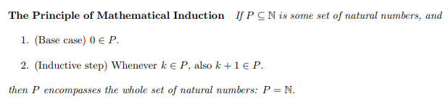

**∈ ELEMENT OF ⊂ SUBSET OF**

**∉ NOT AN ELEMENT ⊆ SUBSET OF OR EQUAL TO**

**∅ EMPTY SET ∪ UNION**

**⋂ N-ARY INTERSECTION ∁ COMPLEMENT**

**Δ SYMMETRIC DIFFERENCE**

It only says that if you’ve got a set that contains 0, and also if you know k + 1 is in the set for every k in the set, then your set is really all of the natural numbers.

1. 0 is in the set because of the base case.
2. And because of the inductive step as well as the fact that you have 0, you must also have **0 + 1 = 1**.
3. And since you have 1 and the inductive step you must also have 2. And since you have 2 you must also have 3
4. And so on; in this way you can **accumulate all the numbers into P**.

### First Example: Section 12.2

If we take P to be “**the set of values n for which this equation is true**”, and establish conditions 1 and 2, then we will have shown that this equation is true for all n. The power here is that in the course of doing this, we will only have had to verify the theorem in one **real case (for 0).** So,

1. First we must show that this equation is true for n = 0. So plugging in 0 for n

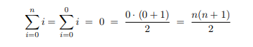

1. We want to **show that whenever this is equation is true for n = k**, **it is also true for n = k + 1**. So we assume that it is true for n = k and set out, given that, to prove that it is true for n = k + 1. Notice this usage of the inductive step as we proceed to the second line.

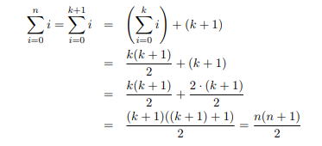(k+1)

Prove that **every amount of postage of 12 cents** **or more** can be formed using just **4-cent and 5-cent stamps**.

**P(n): "Postage of n cents can be formed using 4-cent and 5-cent stamps"**

Claim: **n ≥12, P(n) is true**

Proof by strong induction on n

Base Case: **n = 12, n = 13, n = 14, n = 15**

1. We can form postage of 12 cents using three 4-cent stamps
2. We can form postage of 13 cents using **two 4-cent stamps** and **one 5-cent stamp**.
3. We can form postage of 14 cents using **one 4-cent stamp** and **two 5-cent stamps**.
4. We can form postage of 15 cents using three 5-cent stamps.

Thus, P(n) is true for all elements of the base.

Induction Step: Let n ≥ 15

Assume **P(k) is true for** 12 ≤ k ≤ 15, that is postage of k cents can be formed with 4-cent and 5-cent stamps. [Induction Hypothesis]

To form postage of **n + 1 cents**, use the stamps that form postage of **n - 3 cents** [which exists by I.H.] together with a **4-cent stamp**.

Prove that **P(n + 1)** is also true

### More Examples: Section 12.3

Real numbers are values of a continuous quantity that can represent a distance along a line. The adjective real in this context was introduced in the 17th century by René Descartes, who distinguished between real and imaginary roots of polynomials. The **real numbers** include all the **rational numbers**, such as the integer −5 and the **fraction** 4/3, and all the **irrational numbers**, such as √2 (1.41421356..., the square root of 2, and **irrational algebraic number**). Included within the irrationals are the **transcendental numbers**, such as π (3.14159265...).

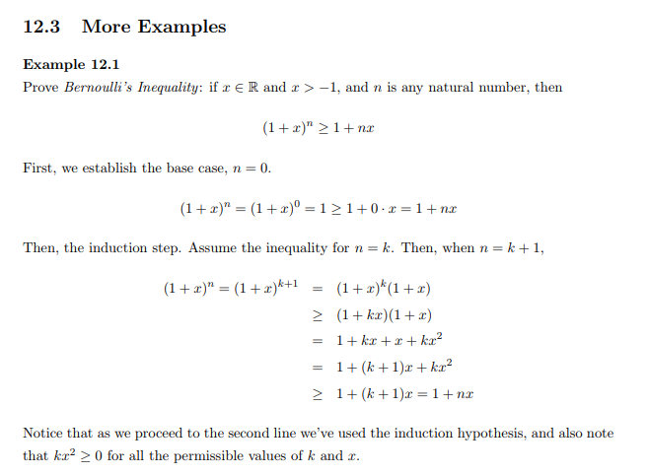

**Example 12.2:**

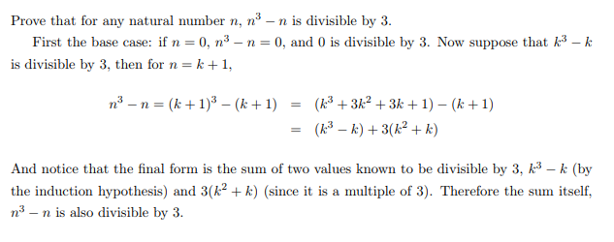

To use Mathematical Induction when you have some other infinite subsets of the natural numbers. For instance, consider this statement: for all n ≥ 5, n2 < 2n. This is true, but the n ≥ 5 part is important since the inequality is false at n = 4 for instance. We can prove it by using a variation of Mathematical Induction where the base case is n = 5 instead of n = 0.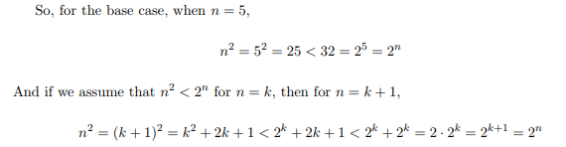

The **first inequality is true by the induction hypothesis**. **The second inequality is true if 2k+1 < 2k**. Given that, we have shown the induction step is true, and therefore our statement, **n2 < 2n is true whenever n ≥ 5.**

One justification for the validity of this variation of Mathematical Induction is that the theorem in question can be viewed as a theorem beginning at n = 0 when written in terms of n + 5, or in this case (n + 5)2 < 2 n+5.

To prove statements about **all even numbers**, for instance. In such a proof we would need to show that n = 0 is true, and that whenever n = k is true then also **n = k + 2** is true. Just as in the base case variation, you could consider such a proof as normal Induction where the theorem is written in terms of 2 · n. Similarly ***you could prove a theorem about all negative integers by using a base case of n = −1 and an induction step in which you use the n = k case to demonstrate the n = k − 1 case***.

## Chapter 13: Recurrences

The **running times** of most inherently **recursive procedures**, such as Merge-Sort, lend themselves to specification and analysis via recurrences.

**A recurrence** is simply **a mathematical formula** which **specifies the running time of the algorithm** **on n elements**, **T(n),** as a **function of the running time on some smaller number of elements** (e.g., T(n/2)) plus some amount of overhead.

For example, consider Merge-Sort. In order to Merge-Sort n elements, one must

1. Recursively call Merge-Sort on the first and second halves of the n elements and then
2. Merge the sorted subgroups returned by the recursive calls.

If we let **T(n) represent the total running time** of Merge-Sort on n elements, then…

1. Step 1 above, T(n/2) must be the running time of Merge-Sort on each of the first and second halves of those n elements.
2. In Step 2, on the order of **n operations is required to merge two sorted groups whose total size is n**. Therefore, the total running time of Merge-Sort, **T(n), is twice T(n/2)** (for the recursive calls) plus on the order of n work to perform the merge.

T(n) = 2T(/2)+n

### Solving Recurrences

Consider our recurrence T(n) = 2T(n/2) + n. In order to solve the recurrence, it is good practice to first rewrite the recurrence with the recursive component last and to use a generic parameter not to be confused with n. We may think of the following equation as our general pattern, which holds for any value of ✷

T(✷) = ✷ + 2 T(✷/2)

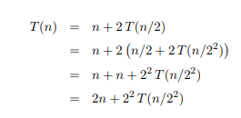

Always simplify the expression, eliminating parentheses and combining terms

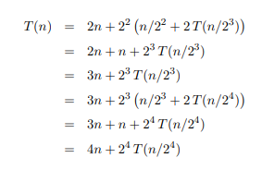

Notice the pattern that has been develop

T(n) = n+2T(n/2) = 2n+2^2T(n/2^2) = 3n+3^3T(n/2^3) = 4n+2^4T(n/2^4)

For k:

Replacing exponent with k

Solve for k:

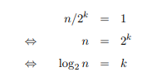

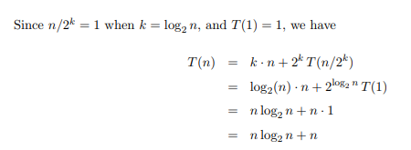

Dropping the lower order term, we have that T(n) is on the order of n log2 n, and we would

Write

Insertion sort algorithm

Thus, Merge-Sort is not quite as fast as linear search, which is Θ(n), but it is faster than

Insertion-Sort, which is Θ(n2).

To complete our analysis, we next prove that the pattern we used was indeed correct; our proof is by induction

Sometimes we can be clever and solve a recurrence relation by inspection. We generate the sequence using the recurrence relation and keep track of what we are doing so that we can see how to jump to finding just the anan term. Here are two examples of how you might do that.

***Telescoping*** refers to the phenomenon when many terms in a large sum cancel out - so the sum “telescopes.” For example:

(2−1)+(3−2)+(4−3)+⋯+(100−99)+(101−100)=−1+101(2−1)+(3−2)+(4−3)+⋯+(100−99)+(101−100)=−1+101 because every third term looks like: 2+−2=0,2+−2=0, and then 3+−3=03+−3=0 and so on.

We can use this behavior to solve recurrence relations.